West Virginia Reading Association’s
65th conference

Submit program proposals on the theme of:
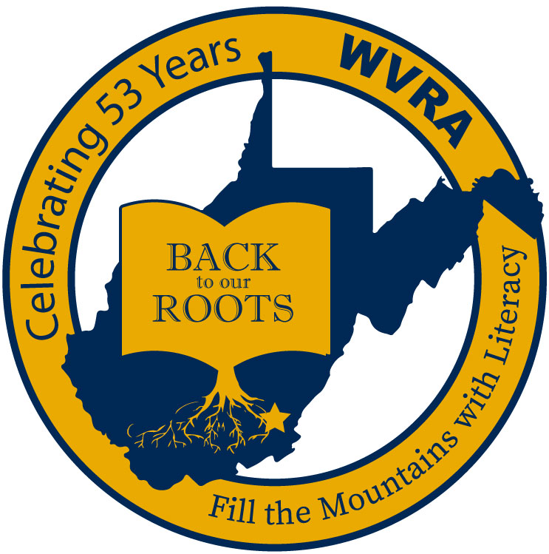
West Virginia Reading Association’s
65th Conference
November 18-19, 2021

The Greenbrier Resort
White Sulphur Springs, West Virginia

PROPOSAL DEADLINE AUGUST 31, 2021

CONFERENCE OVERVIEW
Literacy is an all-encompassing term that includes reading, writing, listening, and speaking. Students need high quality instruction in all these areas to be successful in and out of the school environment. Reading and writing are parallel activities and best practices have revealed that teaching the two together is beneficial instructionally for students. Incorporating listening and speaking enhances the entire literacy experience for students.
In a time where students are easily over-stimulated with various technologies, the simplicity of enjoying the written and spoken word can often times be overlooked. West Virginia is known for its rich history of sharing traditions from one generation to the next through the basic processes of reading, writing, speaking, and listening. Getting “back to our roots” in the classroom and teaching students through effective literacy instruction will ensure that our students will be successful in life.
- WVRA was founded to instill a love and respect for reading in our state
- Reading is emphasized, but best practices suggest that writing, listening and speaking are best taught in conjunction with reading
- The relationship between reading and writing is linear—better readers make better writers, better writers make better readers
- Focus on intertwining the reading and writing processes to enhance our students’ reading AND writing abilities (literacy)
- Incorporate all components of literacy across content areas
- Reading and writing are fundamental and necessary skills for those students on-track for attending college AND those on a career path after high school

Proposal Evaluation Criteria

- Strongly connects to the conference theme – Back to Our Roots: Fill the Mountains with Literacy
- Incorporates technology, intergenerational, civic, or higher education partnerships.
- Adapts instruction for students with diverse and special needs.
- Integrates reading/English language arts instruction in all content areas.
- Integrates reading and writing instruction
- Excluded from selection are (1) incomplete proposals, and/or (2) proposals that promote commercial materials, programs, and/or professional consultants.

Key Deadlines

- THE DEADLINE FOR SUBMITTING PROPOSALS IS AUGUST 31, 2021.
- Notification of a proposal’s acceptance will be e-mailed to the author by September 7, 2021.
- All program presenters must register for the conference and pay conference fees by October 16, 2021.
- General Information
- Mail or electronically submit the complete proposal or proposals on or before AUGUST 31, 2021 to:

Dr. Shelly Ratliff
37 Deer Valley Lane
Glenville, WV 26351
shelly.ratliff@glenville.edu
304-677-9883 (cell)

Word Process and submit this proposal either electronically or through the US Postal Service.

1. Proposal Authors Contact Information.

Name: ______________________________________________
Street Address___________________________________
City__________________ State ________ Zip Code __________
Home: (_____) (_____) (______)
Best time to call __________ AM or PM.
Cell: (_____) (_____) (______)
_____ I would prefer to receive text messages.
E-Mail Address: _______________________________________
Member of WVRA __YES __ NO? Member of ILA __YES __ NO?

2. Other Proposal Presenters Information (Cut, Paste, Complete and Copy item 2 for additional presenters.

Name: ______________________________________________
Street Address___________________________________
City__________________ State ________ Zip Code __________
Home: (_____) (_____) (______)
Best time to call __________ AM or PM.
Cell: (_____) (_____) (______)
_____ I would prefer to receive text messages.
E-Mail Address: _______________________________________
Member of WVRA __YES __ NO? Member of ILA __YES __ NO?

3. Session Proposal Presider Contact Information (If you have your own presider to introduce you. If not we will provide a presider for you.)

Name: ______________________________________________
Street Address___________________________________
City__________________ State ________ Zip Code __________
Home: (_____) (_____) (______)
Best time to call __________ AM or PM.

Cell: (_____) (_____) (______)
_____ I would prefer to receive text messages.

E-Mail Address: _______________________________________
Member of WVRA __YES __ NO? Member of ILA __YES __ NO?

4. Title of the Presentation (Make conferees want to attend this session and please limit the title to ten words or less):

______________________________________________________________________________________________________

5. Program Description for the Conference Program (30 words of less to make conferees want to attend the presentation):

______________________________________________________________________________________________________

______________________________________________________________________________________________________

6. Type of Presentation:
___ Session (45 Minutes) ____ Workshop (90 minutes with a 15 minute in the middle)

7. Scheduling Date and Time Preference (In Order of Preference 1st, 2nd, 3rd:
__ No Preference __ Thursday AM __ Thursday PM __ Friday AM __ Friday PM

8. Topic Relevance and Audience
Reading Topics Inter-Disciplinary Instruction Intended Audience
__Phonemic Awareness __Math __Science __Birth-Pre-K __Title I
__ Comprehension __Social Studies __ Health __Early Childhood (K-2) __ Special Education
__ Phonics __ Fluency __Physical Education __Intermediate (3-5) __ Parents
__Vocabulary __Writing __The Arts __Middle (6-8) __ Community/Civic
__ Writing __ Other Explain. __Foreign Languages __High School __All Attendees

9. Abstract and Session Introduction (Two Additional Attachments)
- On one separate sheet of paper, write a 250 word or less abstract that summarizes the presentation. This summary should include the following:

  - A. The Title of the Program;
  - B. The Program Objective(s);
  - C. The Content to Be Presented;
  - D. Presentation Method(s).

- On another sheet of paper, write a very brief one page introduction to your presentation and biography of the presenters that is pertinent to the
presentation that will make the audience want to hear the presentation. (This sheet is very IMPORTANT, it will be used by your session presider.)

Statement of Intent

The presentation team, presider, and I (the proposal author) understand and agree that if the proposal is accepted by a peer review process, the entire group will:

- Recognizes that the West Virginia Reading Association is a professional, non-profit origination and is unable to provide honoraria or reimburse presenters for materials, travel, technology, fees, meals, or hotel expenses.
- Register for the WVRA Conference and pay all registration fees on or before October 16, 2021.
- Supply the laptop computer/computers or any other audiovisual devices used during the presentation. A projector and screen will be provided by WVRA.
- Prepare and print handouts or materials prior to arrival at the conference.
- Be responsible for paying any fines for copyright violations occurring during the presentation.
- Will not expect the West Virginia Reading Association to reimburse any expenses for members of the team.
- Obtain written parental or legal guardian permission for presentations that use students or student works a part of the presentation.
- Notify Dr. Shelly Ratliff immediately about any changes in the status of this proposal.

Proposal Author’s Signature: ____________________________________
Date: ___________________

Dr. Shelly Ratliff
37 Deer Valley Lane
Glenville, WV 26351
shelly.ratliff@glenville.edu
304-677-9883 (cell)

